Storage Container

The following information describes how PSP pricing works for storage containers and explains the current pricing calculation.

1.
Vendor Pricing QuickBase
2.
Mysql Database
3.
Hub app: Pricing Tool
4.
Sales Management ZTER’s QuickBase

- Records from the Vendor Pricing app in QuickBase are saved into the MySQL database.
There are two ways to keep the records updated:
- Vendor Pricing app in QuickBase: When a new Container is added, or a record is edited or deleted, a webhook is triggered to update the corresponding record in the MySQL database.
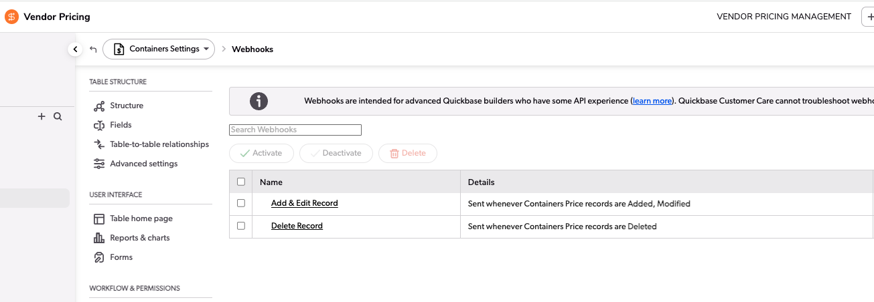
- Hub app: The other way to sync all records is to click the 'Sync' button in Pricing > Settings. This option is only visible to users who belong to the 'ZTERS.VendorManagement' group. This option syncs records for Toilets, Roll-offs, Containers, and Pricing Zones.
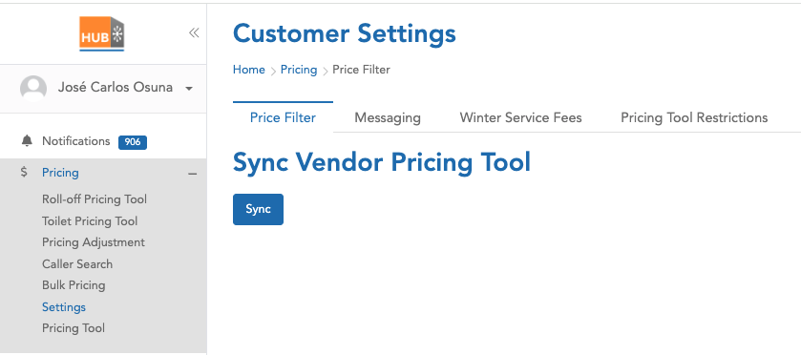
- MySQL database.
The following are the fields saved in the MySQL database, along with their respective sources:

MySQL Field | Vendor Pricing QuickBase | FID
rid | Record ID# | 3
product_category | Product Type - Product Category | 11
product_type | Product Type | 13
pricing_zone_rid | Related Pricing Zone | 20
company_name | Company Name | 22
preferred_vendor | Preferred Vendor | 23
hauler_sales_rid | Hauler - Sales RID | 25
zone_type | Zone Type | 27
zip_list | Zip List | 33
zip_based | Pricing Zone - Zip List - Zip Based | 70
hauler_standard_charge | Standard Charge | 34
hauler_delivery_charge | Delivery Charge | 35
hauler_removal_charge | Removal Charge | 36
hauler_fuel_environ_percent | Fuel Environ % | 37
hauler_fuel_environ_dollars | Fuel Environ $ | 38
hauler_tax_percent | Tax % | 39
hauler_tax_dollars | Tax $ | 40
hauler_other_rate | Other Charge | 41
hauler_description | Other Description | 42
hauler_frequency | Other Billing Frequency | 43
hauler_dry_run_rate | Dry Run | 44
hauler_relocation_rate | Relocation | 45
address_miles | Pricing Zone - Address Miles | 59
depot_address | Pricing Zone - Depot Address | 60
depot_zip_code | Pricing Zone - Depot Address: Postal Code | 64
radius_miles | Pricing Zone - Radius Miles | 65
customer_standard_charge | Suggested Standard Charge 35% | 50
customer_delivery_charge | Suggested Delivery Charge 35% | 51
customer_removal_charge | Suggested Removal Charge 35% | 52
customer_total_charge | Suggested Total Charge | 58
pricing_zone_dnu | Pricing Zone - DNU | 76
dnu | DNU | 77
dnu_zone_or_individual | DNU - Zone or Individual | 78
added_rid | Internal | NA

- Hub app > Pricing Tool.
By applying filters such as Zip code and address, the Pricing tool in the Hub app shows records or suggestions based on the data stored in our database, originally imported from QuickBase.
The following are the columns shown for Containers:
Column | MySQL Field
Provider Name | company_name
Category | product_category
Size | product_type
Rental / 28 days | customer_standard_charge
Delivery | customer_delivery_charge
Removal | customer_removal_charge

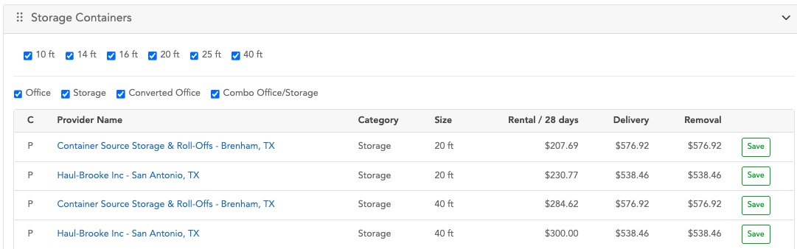
The value shown in the 'Rental / 28 days' column is, in some cases, different from the one saved in MySQL because a process applies certain pricing adjustments. These adjustments are designed to increase or decrease the final amount in that column and can be applied selectively to specific record IDs.

Pricing adjustments process:
- Try to find in “pricingadjustment” table a record filtering by:
- Active
- Product: ‘all’ or ‘storage-container’
- is_applicable: ‘%Hub Pricing Tool%’
If there are no records in the previous table, no pricing adjustments are applied.
- The second step is to try to apply additional filters to the records retrieved from step 1:
- Check the expiration logic: if the 'is_expire' flag is set to '1' and the 'expire_date' is greater than or equal to the current date, or if the 'is_expire' flag is '0', the record continues processing.
- The second filter logic checks the value of the 'geography' column: records with the value 'all', or where the zip code is included in the list, are allowed to continue processing.
- The third step is to sort the records by priority and apply only the record with the highest priority.
Also, in a hierarchical manner, check whether it is necessary to apply the adjustment for specific PSPs:
- This applies if the record is of type 'some PSPs' or 'some confirmed prices', and the 'storage_container_id' column is not empty. If so, verify whether the suggestion record is included in the IDs stored in the 'storage_container_id' column.
- If the previous conditions are false, check whether the record type is 'all' or 'all PSPs', or if the product has a value of 'all'.
- The final record from the 'pricingadjustment' table determines the amount to be increased or decreased. This adjustment can be applied to all records shown as suggestions, or to a specific record ID, depending on the value of the 'type' column (e.g., 'some PSPs' or 'some confirmed prices').
  - If the “price_flag” column has a value of “1”, the value in the “amounts” column is directly considered as the amount to increase or decrease from the final total.
  - If the “price_flag” column has a value of “0”, the system takes the value from the “percentage” column, divides it by 100, and multiplies the result by the original value from “customer_standard_charge”. This calculated value is then used to increase or decrease the final total.
  - To determine whether the adjustment is an addition or a subtraction, the system uses the value in the “price” column, which indicates either increase or decrease.

- When the user clicks the Save button, a “Container” is created in the Sales Management ZTERs app in QuickBase.
The new container record is created based on the following information:
Sales Management ZTER’s QuickBase | FID | MySQL Field | Rounded?
Site ID | 58 | Parameters from the request
Category | 341 | product_category
Status | 22 | “Quote in Progress”
Product Type | 344 | According the size (10ft, 20 ft, 40ft)
Standard Charge (Customer) | 14 | customer_standard_charge | Yes
Delivery Charge (Customer) | 12 | customer_delivery_charge | Yes
Removal Charge (Customer) | 13 | customer_removal_charge | Yes
Pricing Tool Quote | 748 | 1
Pricing Tool Delivery Charge | 749 | customer_standard_charge | Yes
Pricing Tool Rental Charge | 750 | customer_delivery_charge | Yes
Pricing Tool Qty | 751 | 1
Pricing Tool Diagnostics | 753 | Parameters from the request
Hauler ID | 57 | hauler_sales_rid
Pricing Tool - Vendor List | 754 | hauler_sales_rid
Pricing Tool - Zone RID | 755 | pricing_zone_rid
Delivery Charge (Hauler) | 7 | hauler_delivery_charge
Removal Charge (Hauler) | 8 | hauler_removal_charge
Standard Charge (Hauler) | 9 | hauler_standard_charge
Fuel Environ Percent (Hauler) | 10 | hauler_fuel_environ_percent
Fuel Environ Dollars (Hauler) | 11 | hauler_fuel_environ_dollars
% Tax (Hauler) | 112 | hauler_tax_percent
Tax $ (Hauler) | 166 | hauler_tax_dollars
Other Charge (Hauler) | 110 | hauler_other_rate
Other Description (Hauler Rate) | 373 | hauler_description
Other Billing Frequency (Hauler Rate) | 374 | hauler_frequency
Dry Run (Hauler) | 378 | hauler_dry_run_rate
Relocation (Hauler) | 380 | hauler_relocation_rate

As part of the new record, a note is added with specific information such as Hauler ID, Hauler Name, Category, Type, Standard Charge, Delivery Charge, and Removal Charge. For these charges, both the original value and the rounded price are included.

Example:
Hub app: Pricing Tool
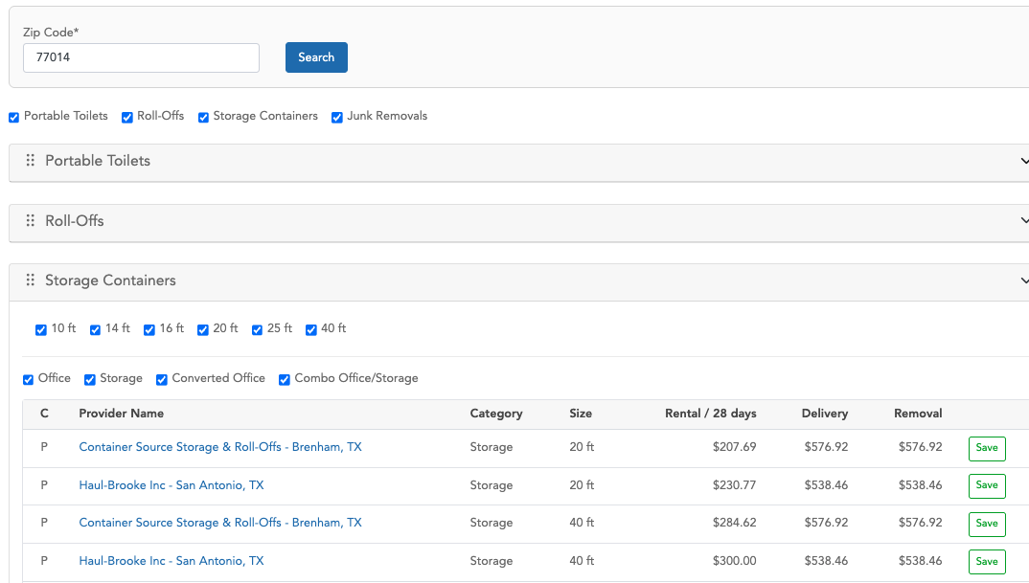
The following record was created using the first suggestion from the table, after clicking the Save button
https://zters.quickbase.com/nav/app/bhwfnx4uw/table/bhwgtqvvi/action/er?rid=53902

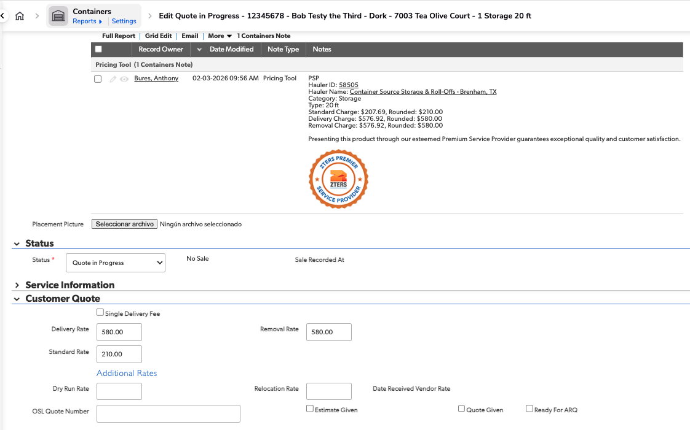
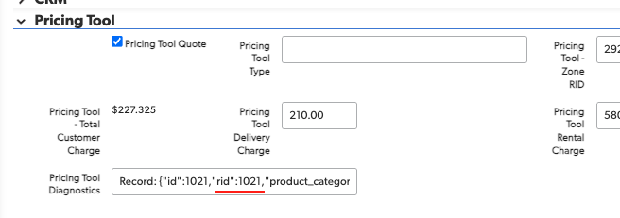
There is a Pricing Tool section in the Administrative tab. It displays the ID from the Vendor Pricing QuickBase, which, in this case, is record 1021.
https://zters.quickbase.com/nav/app/brd5gaz5n/table/breujuw2t/action/dr?rid=1021&rl=b8s
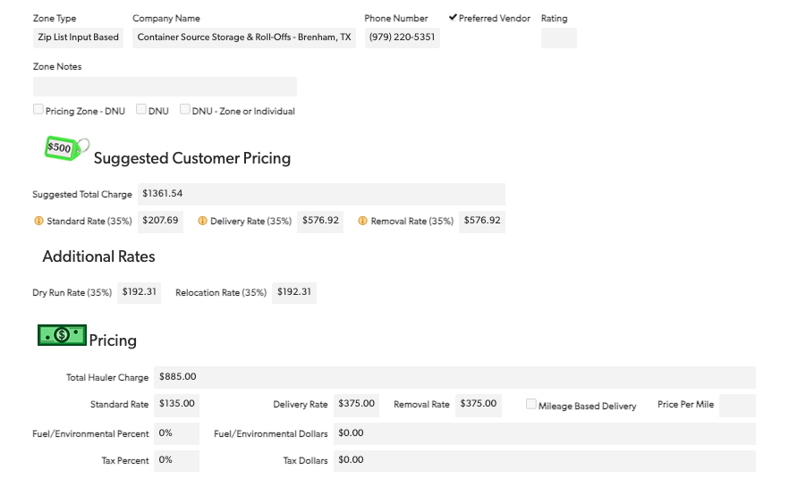
As you can see, the Standard Rate (35%), Delivery Rate (35%), and Removal Rate (35%) are the same as the values displayed in the Pricing Tool in the Hub app.

